**QGIS Instructions**

Last updated: 6/21/2021

1. Install [QGIS](https://www.qgis.org/en/site/) on your computer
2. Open QGIS
3. Navigate to *Data Source Manager*
   1. 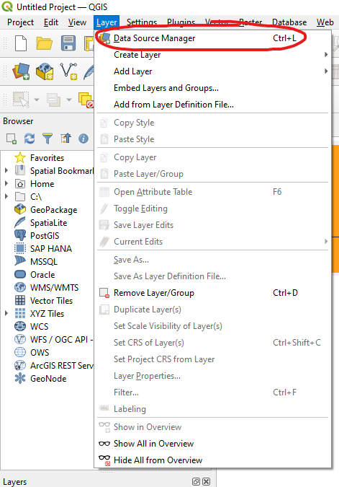
4. Click on *Vector*, then click on the ellipses to select a file
   1. 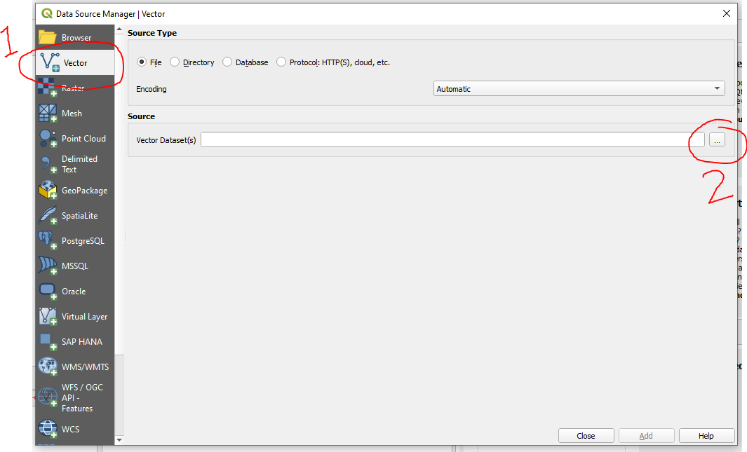
5. Select the city boundaries .shp file (a .zip file containing this file can be downloaded from [previous releases](https://github.com/laregionalcollaborative/Climate-Resolve-Matrix-Parser/releases)), then *Open*
   1. 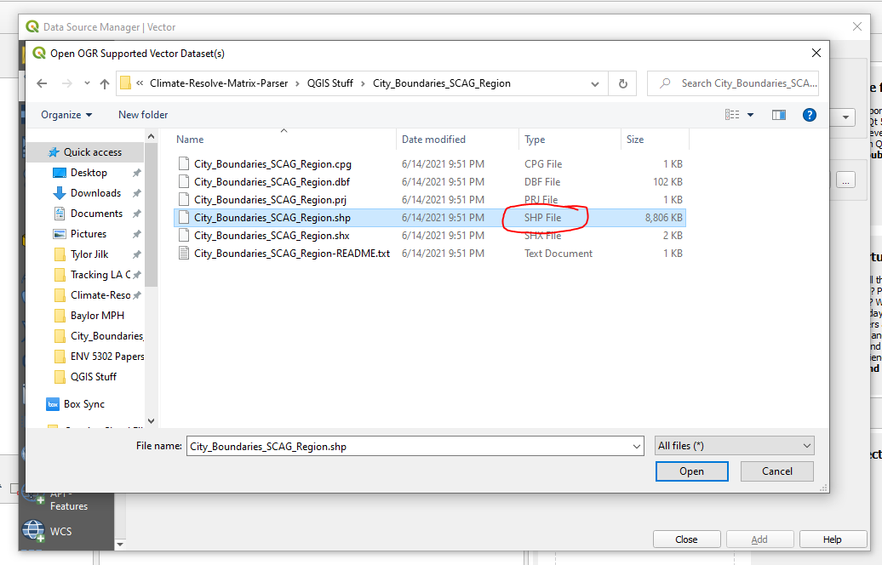
6. Click on *Add*, then *Close*
   1. 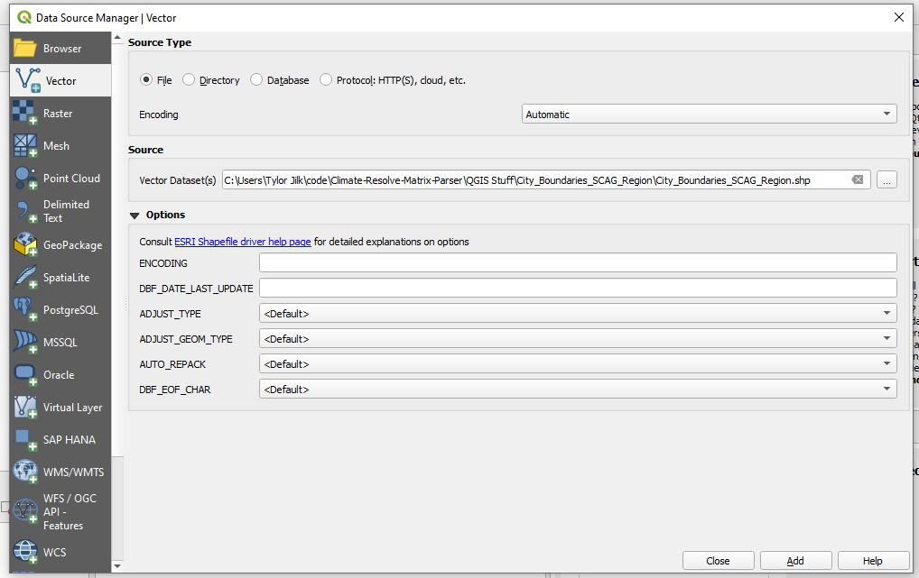
7. Your window should now look like this, showing the entire SCAG area with city boundaries. Note that the layer has been imported in the lower left.
   1. 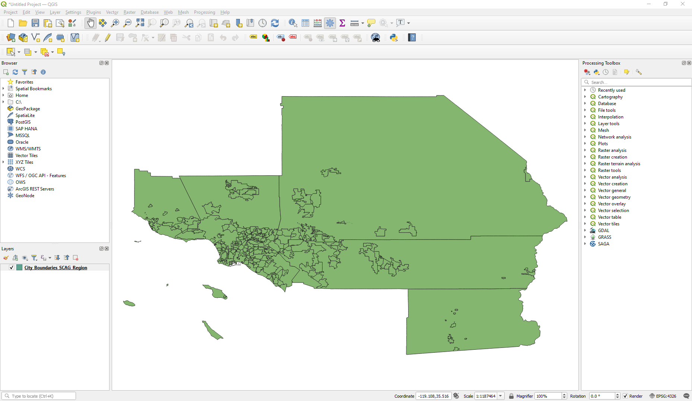
8. Navigate to *Data Source Manager* once again
   1. 
9. This time, go to *Delimited Text*, and then click on the ellipses to select a file
   1. 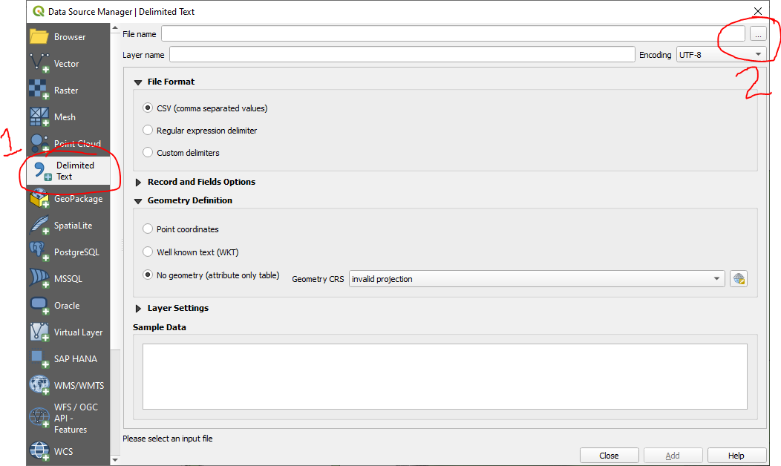
10. Select the output csv file containing the cap_map data, then *Open*
    1. 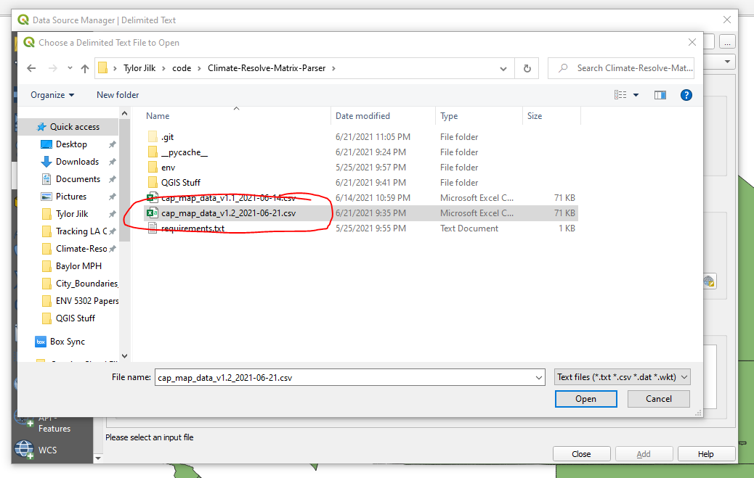
11. Click on *Add*, then *Close*
    1. 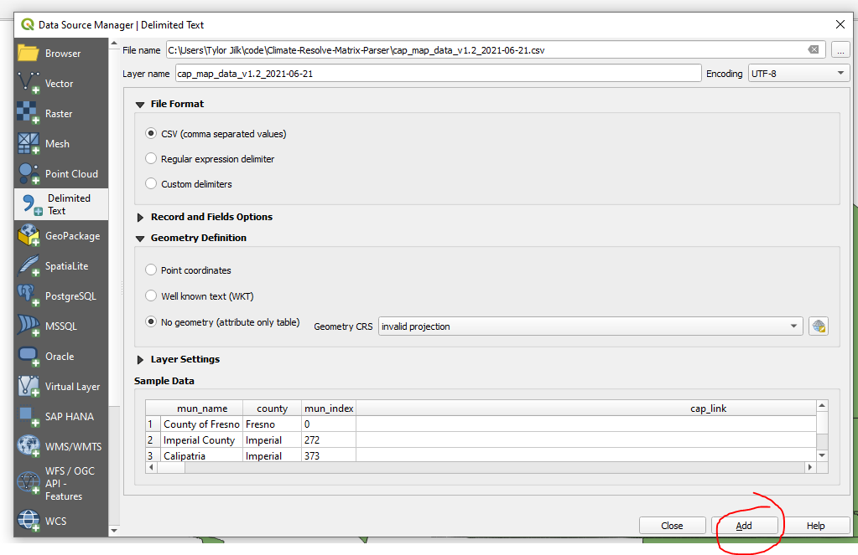
12. The newly added file should appear in the lower left of the screen under *Layers*:
    1. 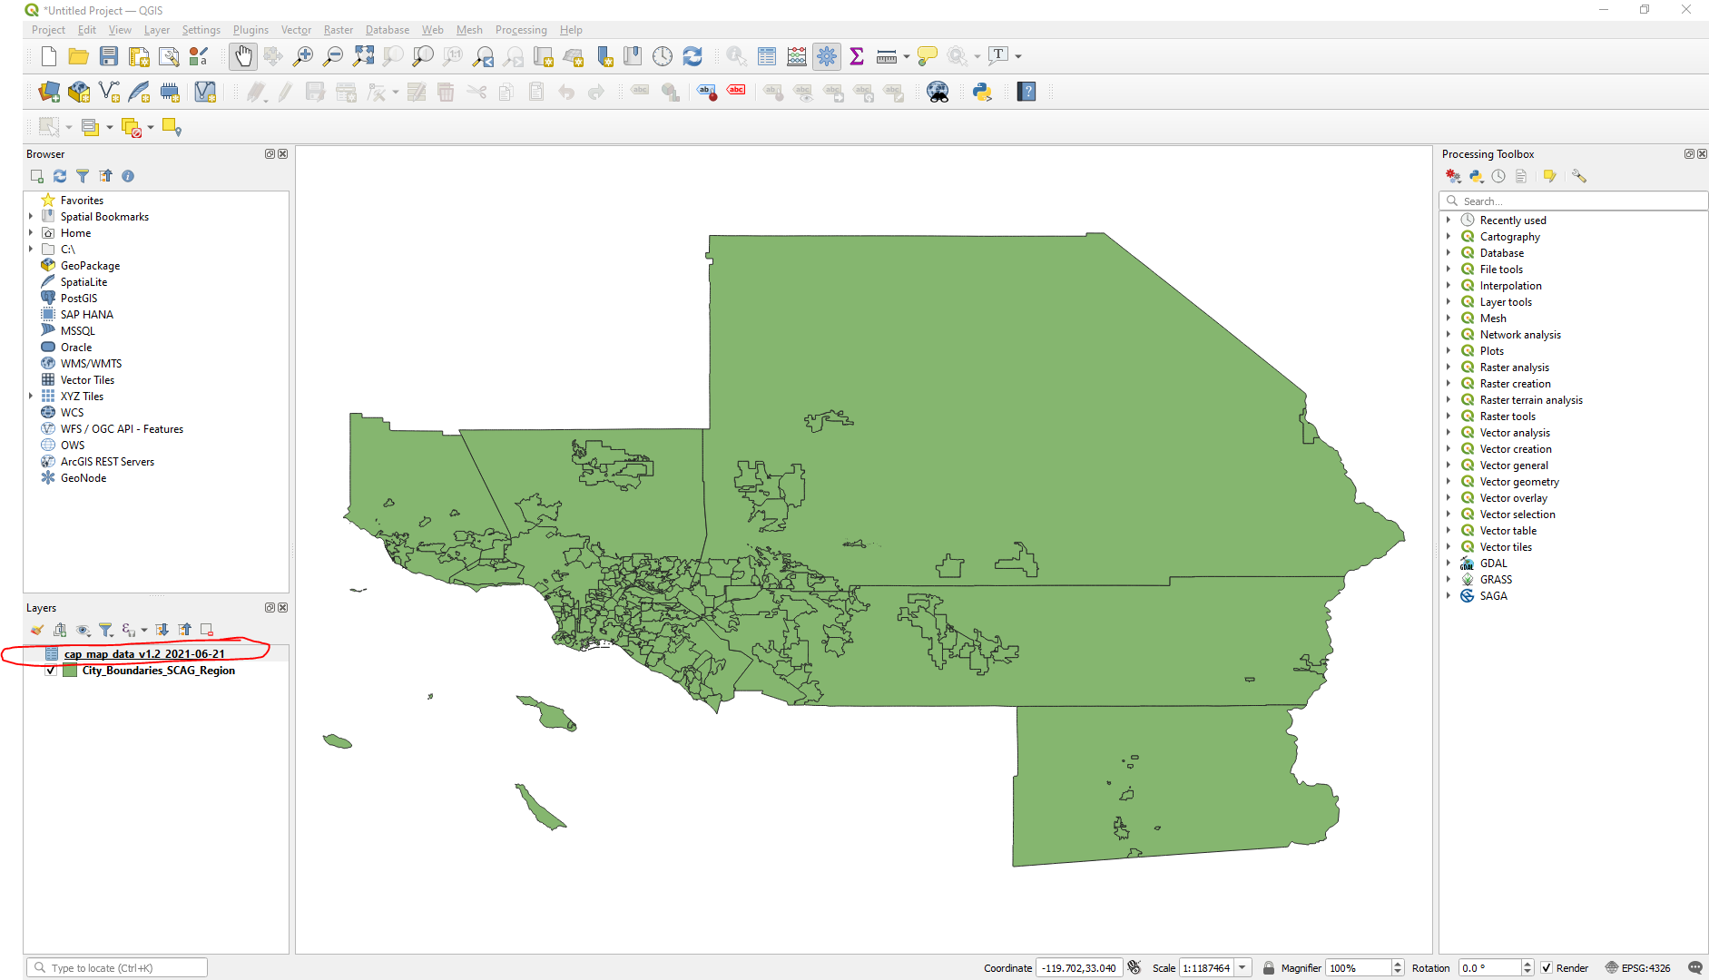
13. Open the *Processing Toolbox* if not already present on the right hand side:
    1. 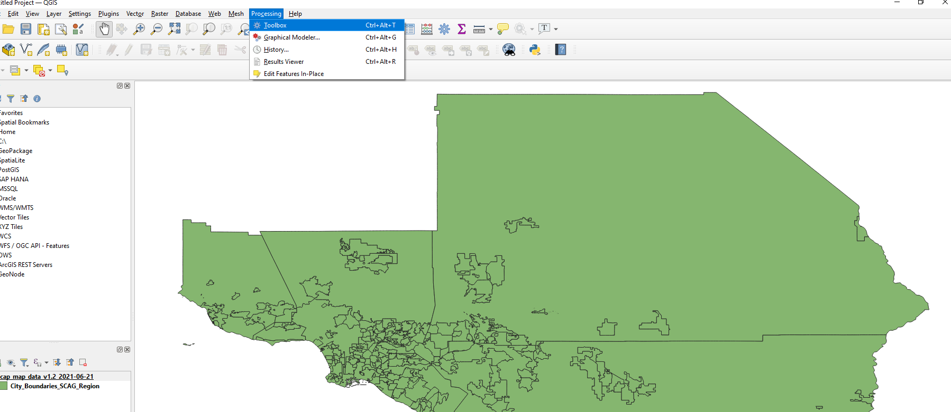
14. Search for “join attributes by field value”, then double-click the relevant option under *Vector general*
    1. 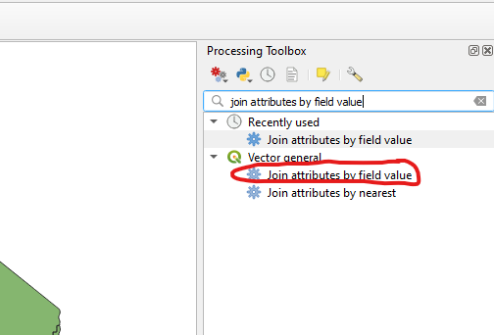
15. Join the attributes
    1. Input Layer = SCAG Region file, with Table field OBJECTID
    2. Input Layer 2 = cap_map data, with Table Field 2 = mun_index
    3. Select the unjoinable features from the first layer to create a temporary layer
    4. 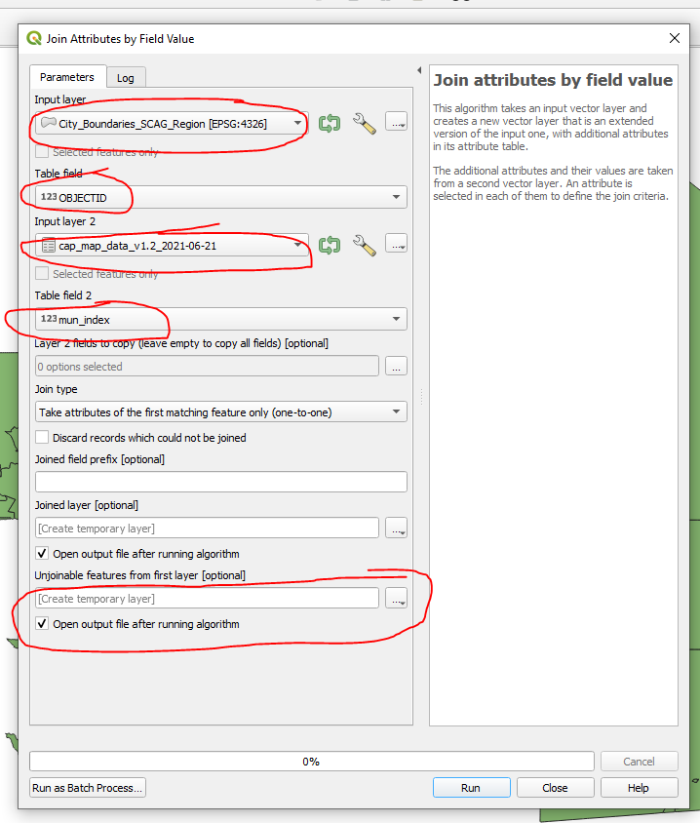
    5. Click *Run*
16. Verify that the ‘UNJOINABLE_COUNT’ is zero, which means that all municipalities were accounted for during the joining process
    1. (example output)
    2. 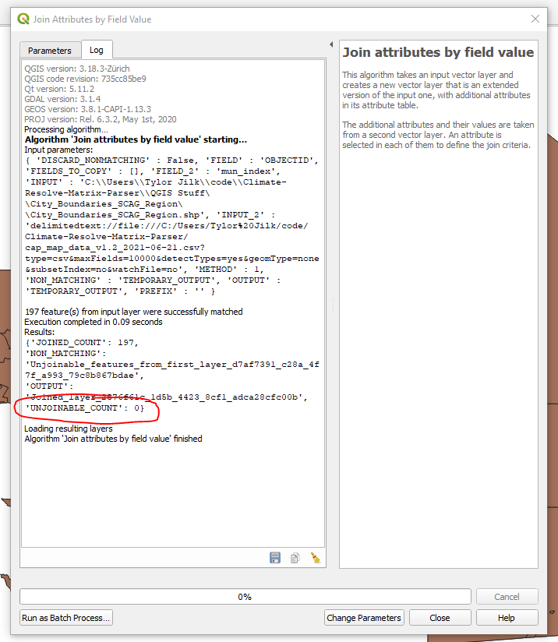
    3. Click *Close*
17. To export the file in a format that Carto can accept, navigate to *Layer* 🡪 *Save As…*
    1. 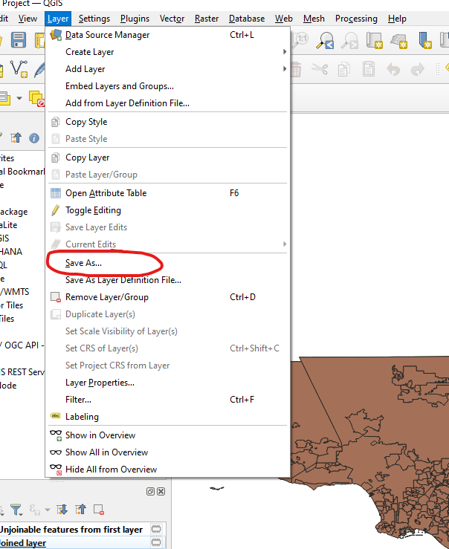
18. Ensure ‘ESRI Shapefile’ is the format selected, then click on the ellipses to set the output files
    1. 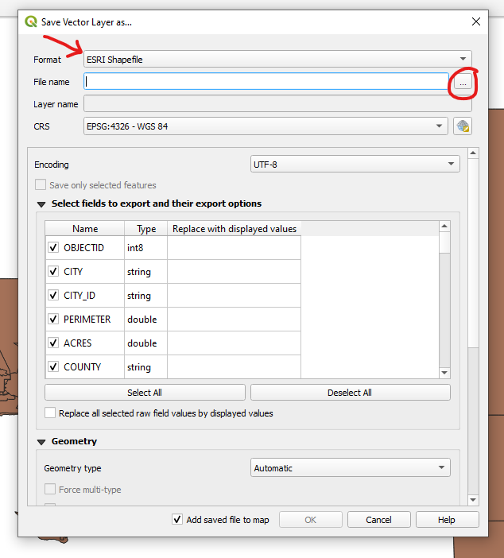
19. In the output directory (in this example I created a new folder called ‘output’), multiple files will be generated. However, here we give them a single name and ensure that it is being saved as an ESRI Shapefile:
    1. 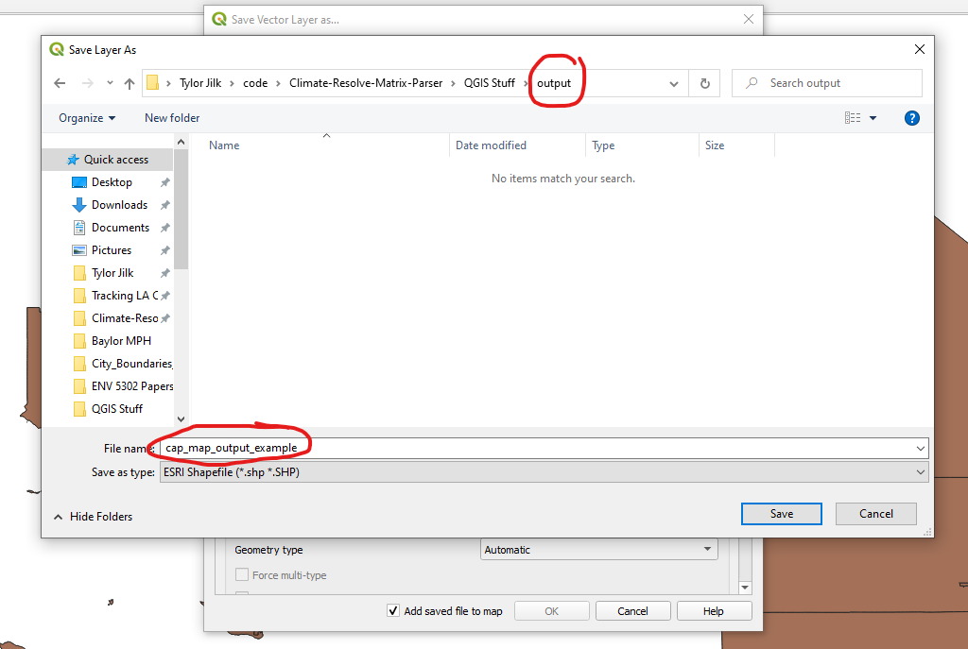
    2. Click *Save*
20. Click *OK*
    1. 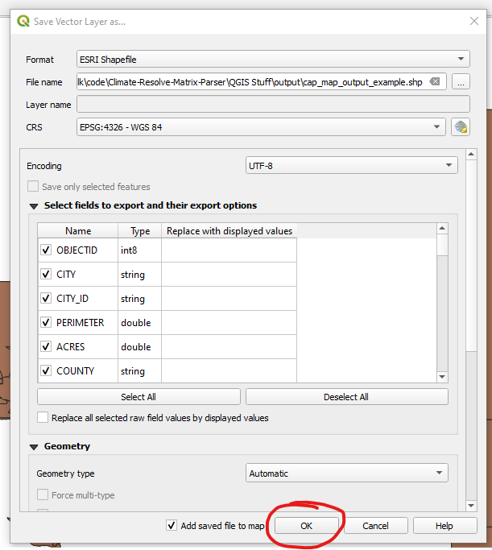
21. A total of 5 files should now be present in the output folder previously specified.
    1. 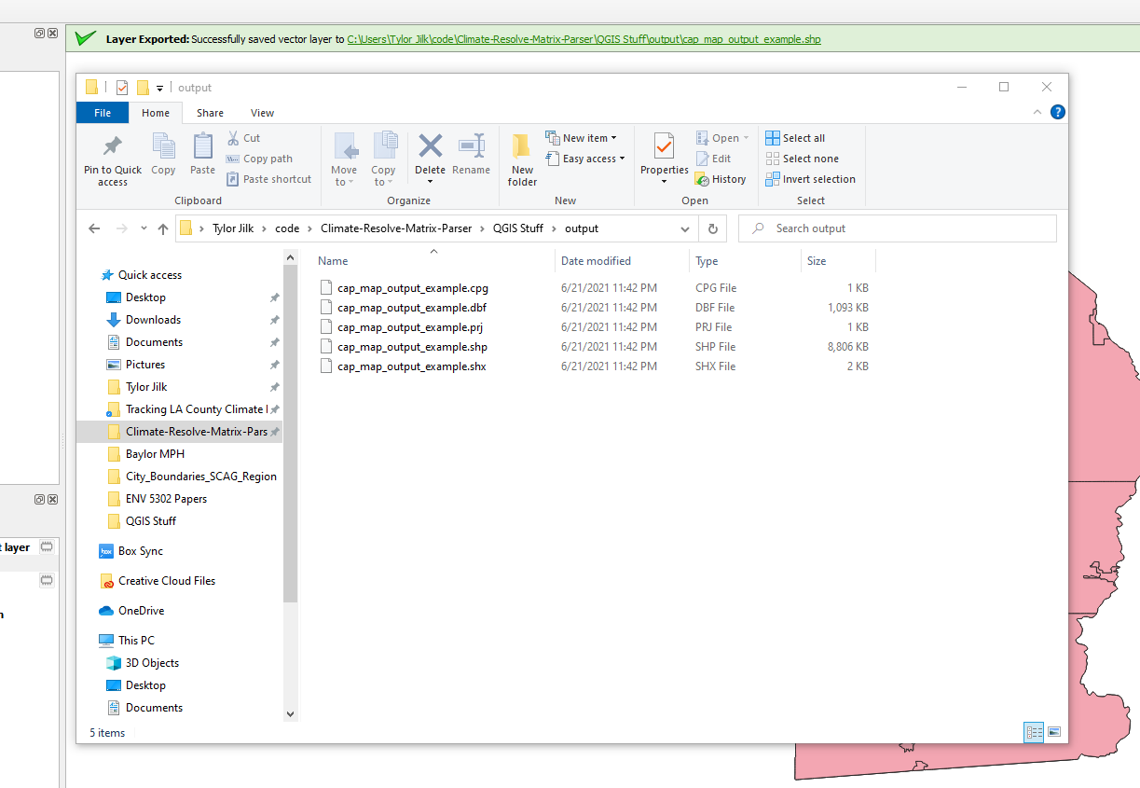
22. Select all the files, right click, and zip them together into a single .zip file
    1. 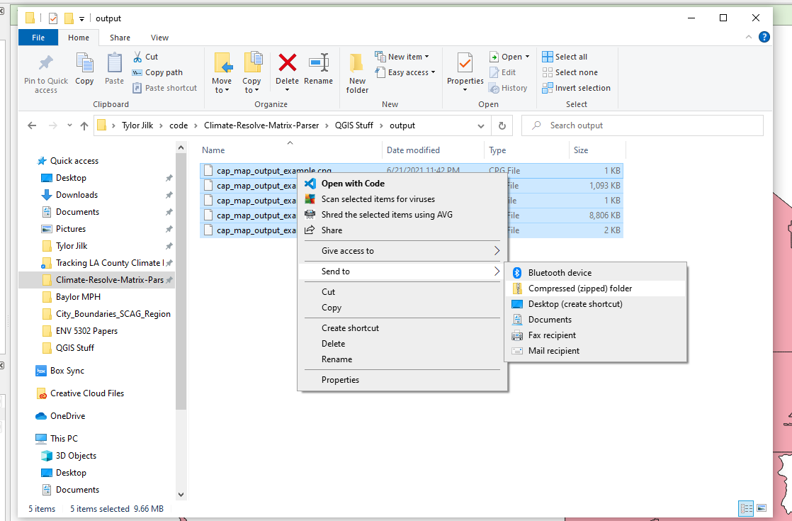
    2. 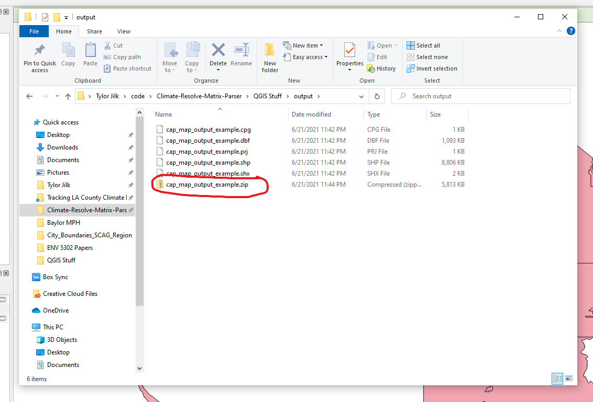
23. This .zip file can be imported directly into Carto as a Shapefile dataset
    1. 